**WEEK 5 MANDATORY HANDS-ON**

**CREATING MICROSERVICES FOR ACCOUNT AND LOAN**

**Account:**

**AccountController.java :**

package com.cognizant.account.controller;

import org.springframework.web.bind.annotation.*;

import java.util.Map;

@RestController

public class AccountController {

@GetMapping("/accounts/{number}")

public Map<String, Object> getAccount(@PathVariable String number) {

return Map.of(

"number", number,

"type", "savings",

"balance", 234343

);

}

}

**OUTPUT:**

http://localhost:8080/accounts/00987987973432

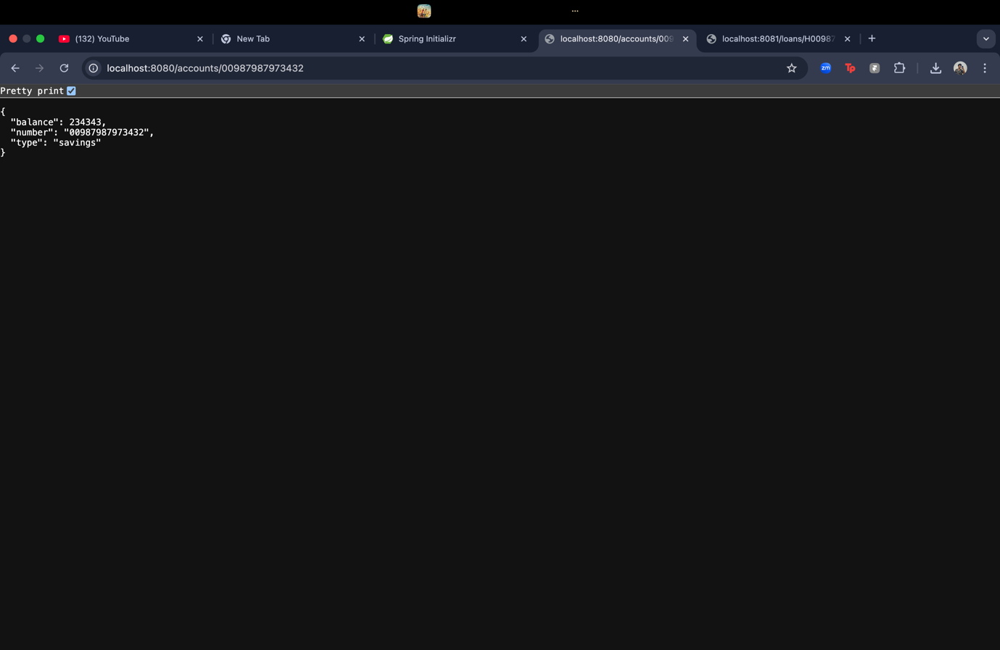

**LoanController.java :**

package com.cognizant.loan.controller;

import org.springframework.web.bind.annotation.*;

import java.util.Map;

@RestController

public class LoanController {

@GetMapping("/loans/{number}")

public Map<String, Object> getLoan(@PathVariable String number) {

return Map.of(

"number", number,

"type", "car",

"loan", 400000,

"emi", 3258,

"tenure", 18

);

}

}

**OUTPUT :**

[**http://localhost:8081/loans/H00987987972342**](http://localhost:8081/loans/H00987987972342)

